SEAFLOOR MAPPING AND MARINE PROVINCES
NAME:
SUBJECT: GEOL1551
8TH SEPT 2020

Objectives
To understand methods of mapping the seafloor and how data may be presented and interpreted.
To discover some important geographic features in the ocean basins.
To understand the characteristics of different marine provinces.
Theory
Ocean depths and topography of the ocean floor can be determine by using echo sounding, side scan sonar, seismic reflection profiles or satellite measurements. The most commonly used methods are the multibeam echo sounders and side -scan sonar.
There are 3 major ocean provinces, the continental margins which are located in shallow water areas closer to the shore. There are Deep ocean basins located in deep water areas far away from the shore and there is Mid-ocean ridge, which are generally submarine mountain ranges.

Questions and Discussions
- Seafloor Mapping
- The known water depth is 4500 m. An acoustic energy pulse travels down and back in 6 seconds. What is the velocity of the acoustic energy through the seawater medium? *Remember your units!*
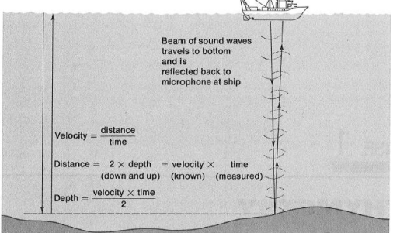
Velocity = $\frac{Depth*2}{time}$ = $\frac{4500*2}{6}$ = 1500m/s
- How deep is the water where the two-way travel time of an acoustic pulse is 3.0 seconds?
Depth = $\frac{Velocity*time}{2}$ = $\frac{1500*3 }{2}$ = 2250m

- Multibeam Sonar

- Explain how the multibeam data are presented to illustrate the depth and relief.

Multibeam sonar adopts the technique of using multiple transducers designed to point at different angles and directions on either sides of the ship, creating a swath of signals.
To estimate the sea depth, time interval between the signal transmission and the returning echo over the area of the swath is used.
Multibeam data then creates a three dimensional models that simulate a trip across the area of the swatch.

- Side-scan sonar
- Give two examples for how you would use:
- Multibeam data.
Using an echo sounder to map the seabed by emitting sound waves which on getting reflected from the seabed, one can estimate the depth of the sea.
Creating a three dimensional model/ fly over that simulates the trip across the area of the swath showing the depths and elevations of the area.
- Side-scan sonar data.
Creating an image of large areas of the seabed through creation of nautical charts which enables mapping of the seabed hence one is able to establish the features existing below the sea.
Detecting and identifying underwater bathymetric features and objects through down-imaging and side- imaging.

- Marine Provinces and Geography
- Fly to latitude 31 degrees 2 minutes north, and longitude 42 degrees 4 minutes west (you’ll need to type it as 31 2’N, 42 4’W). What marine province is this? mid-ocean ridges
- What would the valley (oriented north-south) be called just east of this site?
The Rift Valley
- What marine province exists at 13 degrees south, 5 degrees east?
13 0’S, 5 0’E is a marginal ocean province

- Fly to latitude 1 degrees 14 minutes north, and longitude 46 degrees 40 minutes west. What marine province is this (note how depths are rapidly increasing)?
1 14’N, 46 40’W is a deep ocean basin province

- Fly to latitude 2 degrees 17 minutes north and longitude 48 degrees 51 minutes west. What marine province is this?
2 17’N, 48 51’W is a marginal ocean province

- Just to the northeast of this site, what is the v-shaped structure cutting into this marine province? Amazon Canyons

- Fly to the Japanese Islands. What do we call this variety of volcanic islands that are arranged in an arc-like fashion? Volcanic arcs islands.
- What kind of tectonic boundary occurs at these islands (be specific as far as types of crust and how they are interacting)? Convergent tectonic plate boundaries.

- Fly to 17 degrees S, 74 degrees W (19 00’S, 72 00’W). What marine province is this?
19 00’S, 72 00’W is a marginal ocean province.

- Is this province an indication of an active or passive continental margin?
An active continental margin

- What is the depth in feet here? (Place the mouse hand over the location and look at the elevation given at the bottom of the frame, next to the latitude and longitude).
The depth feet is 22800 ft

- What is the depth in meters?
1 ft = 0.3048 m
22800ft = 6950 m

- Fly to the Marshall Islands. Note the similar orientation of this string of islands and seamounts to the Emperor Seamounts in the North Pacific. How do you suppose the Marshall Islands formed?
Marshall Highlands formed through Geological Formation whereby a volcanic highland might have sank into the sea.

- Below is a list of oceanographically/geologically interesting and important features, some of which will be discussed in lectures. Locate the following features in Google Earth (you might need to do a Google search initially). Add a pin on your globe for each location and give it the corresponding name.
Change the label and icon scale to 3.

• Faeroe Islands • Romanche Fracture Zone • Walvis Ridge • Rio Grande Rise • Kerguelan Plateau • Challenger Deep/Mariana Trench • Ninety East Ridge • Juan de Fuca Plate • Central Indian Ocean Ridge • Great Barrier Ree
Azores • Puerto Rico trench • South Sandwich Island trench • East Pacific Rise • Galapagos Islands and Hot Spot , Red Sea • Persian Gulf • Beaufort Sea • Aleutian Island Trench • West African Shelf

• Faeroe Islands • Romanche Fracture Zone
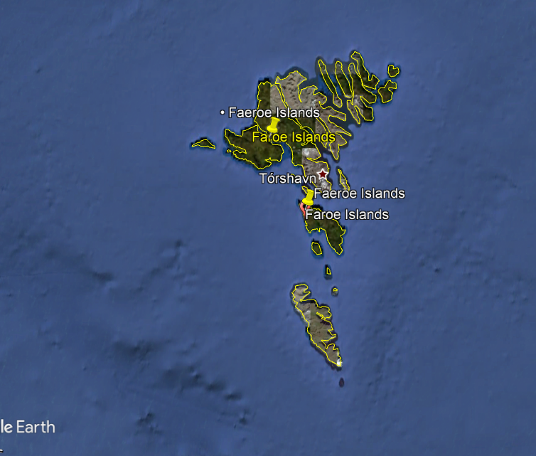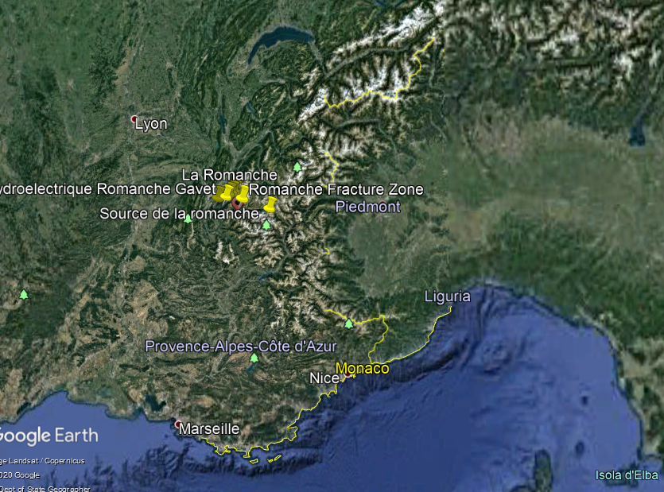

• Walvis Ridge • Rio Grande Rise
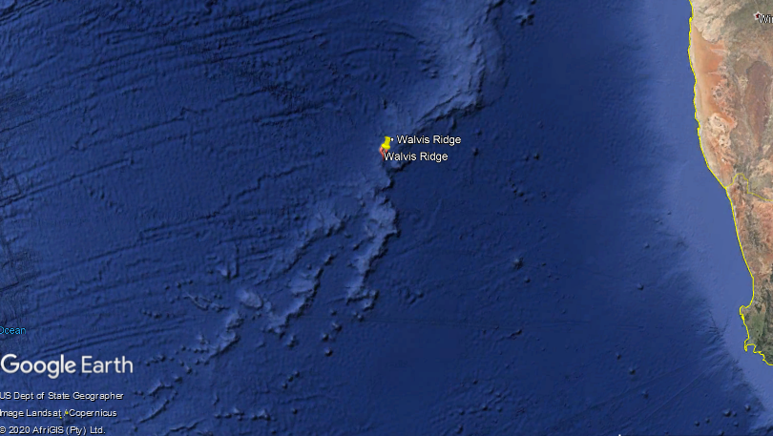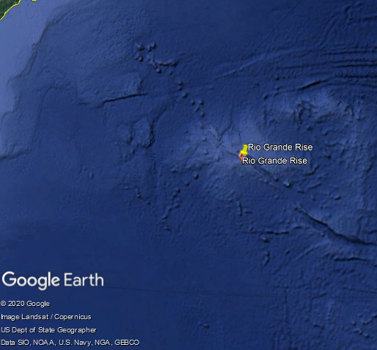

• Kerguelan Plateau • Challenger Deep/Mariana Trench
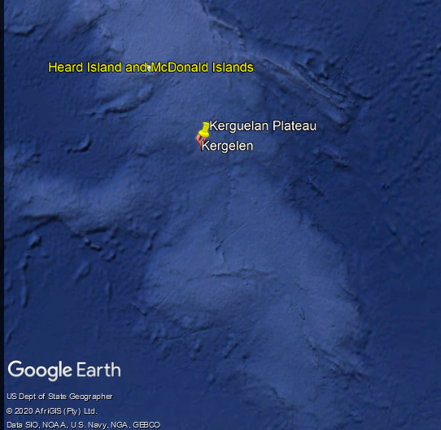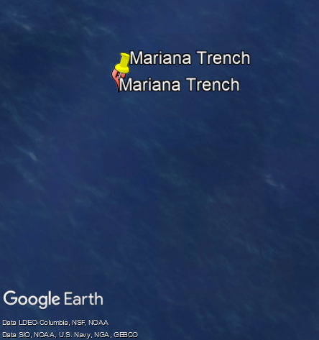

• Ninety East Ridge • Juan de Fuca Plate
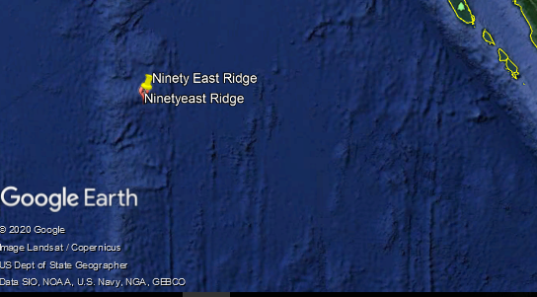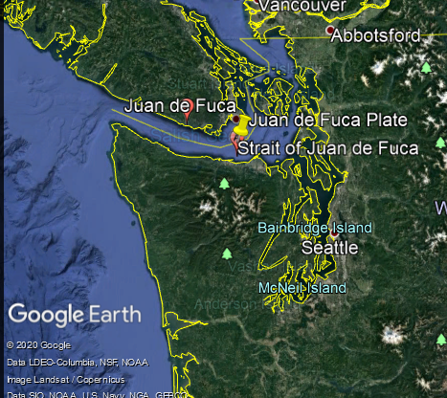

• Great Barrier Ree Red Sea
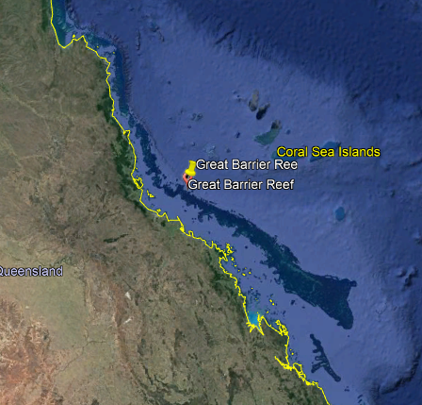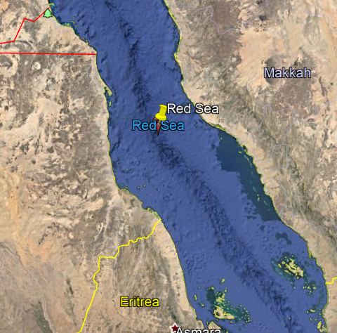
• Persian Gulf • Beaufort Sea
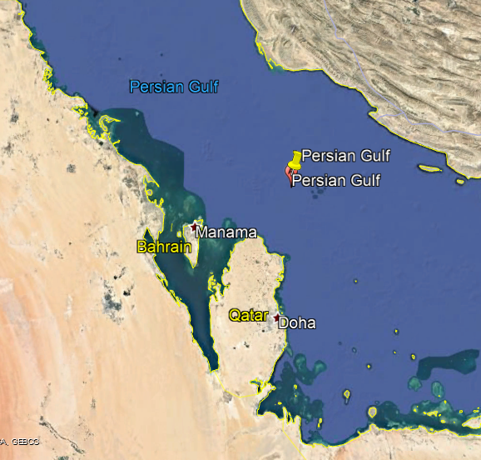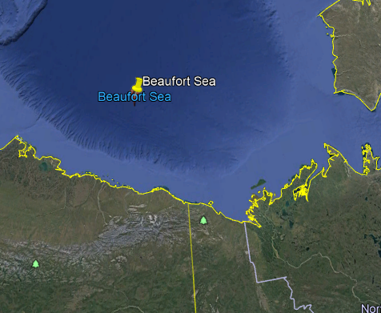
• Aleutian Island Trench • Azores
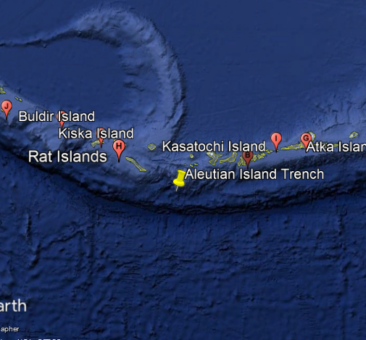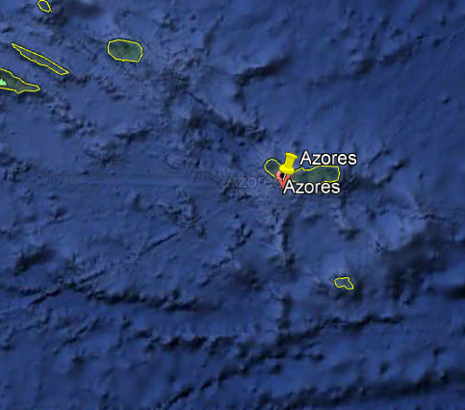
• Puerto Rico trench • East Pacific Rise
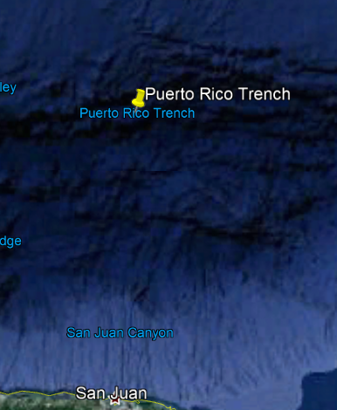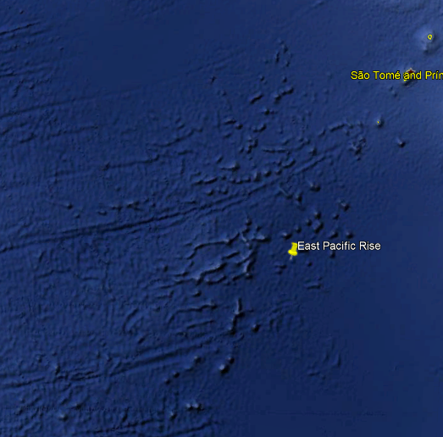

• Galapagos Islands and Hot Spot

